KARNATAKA VETERINARY, ANIMAL & FISHERIES SCIENCES UNIVERSITY,
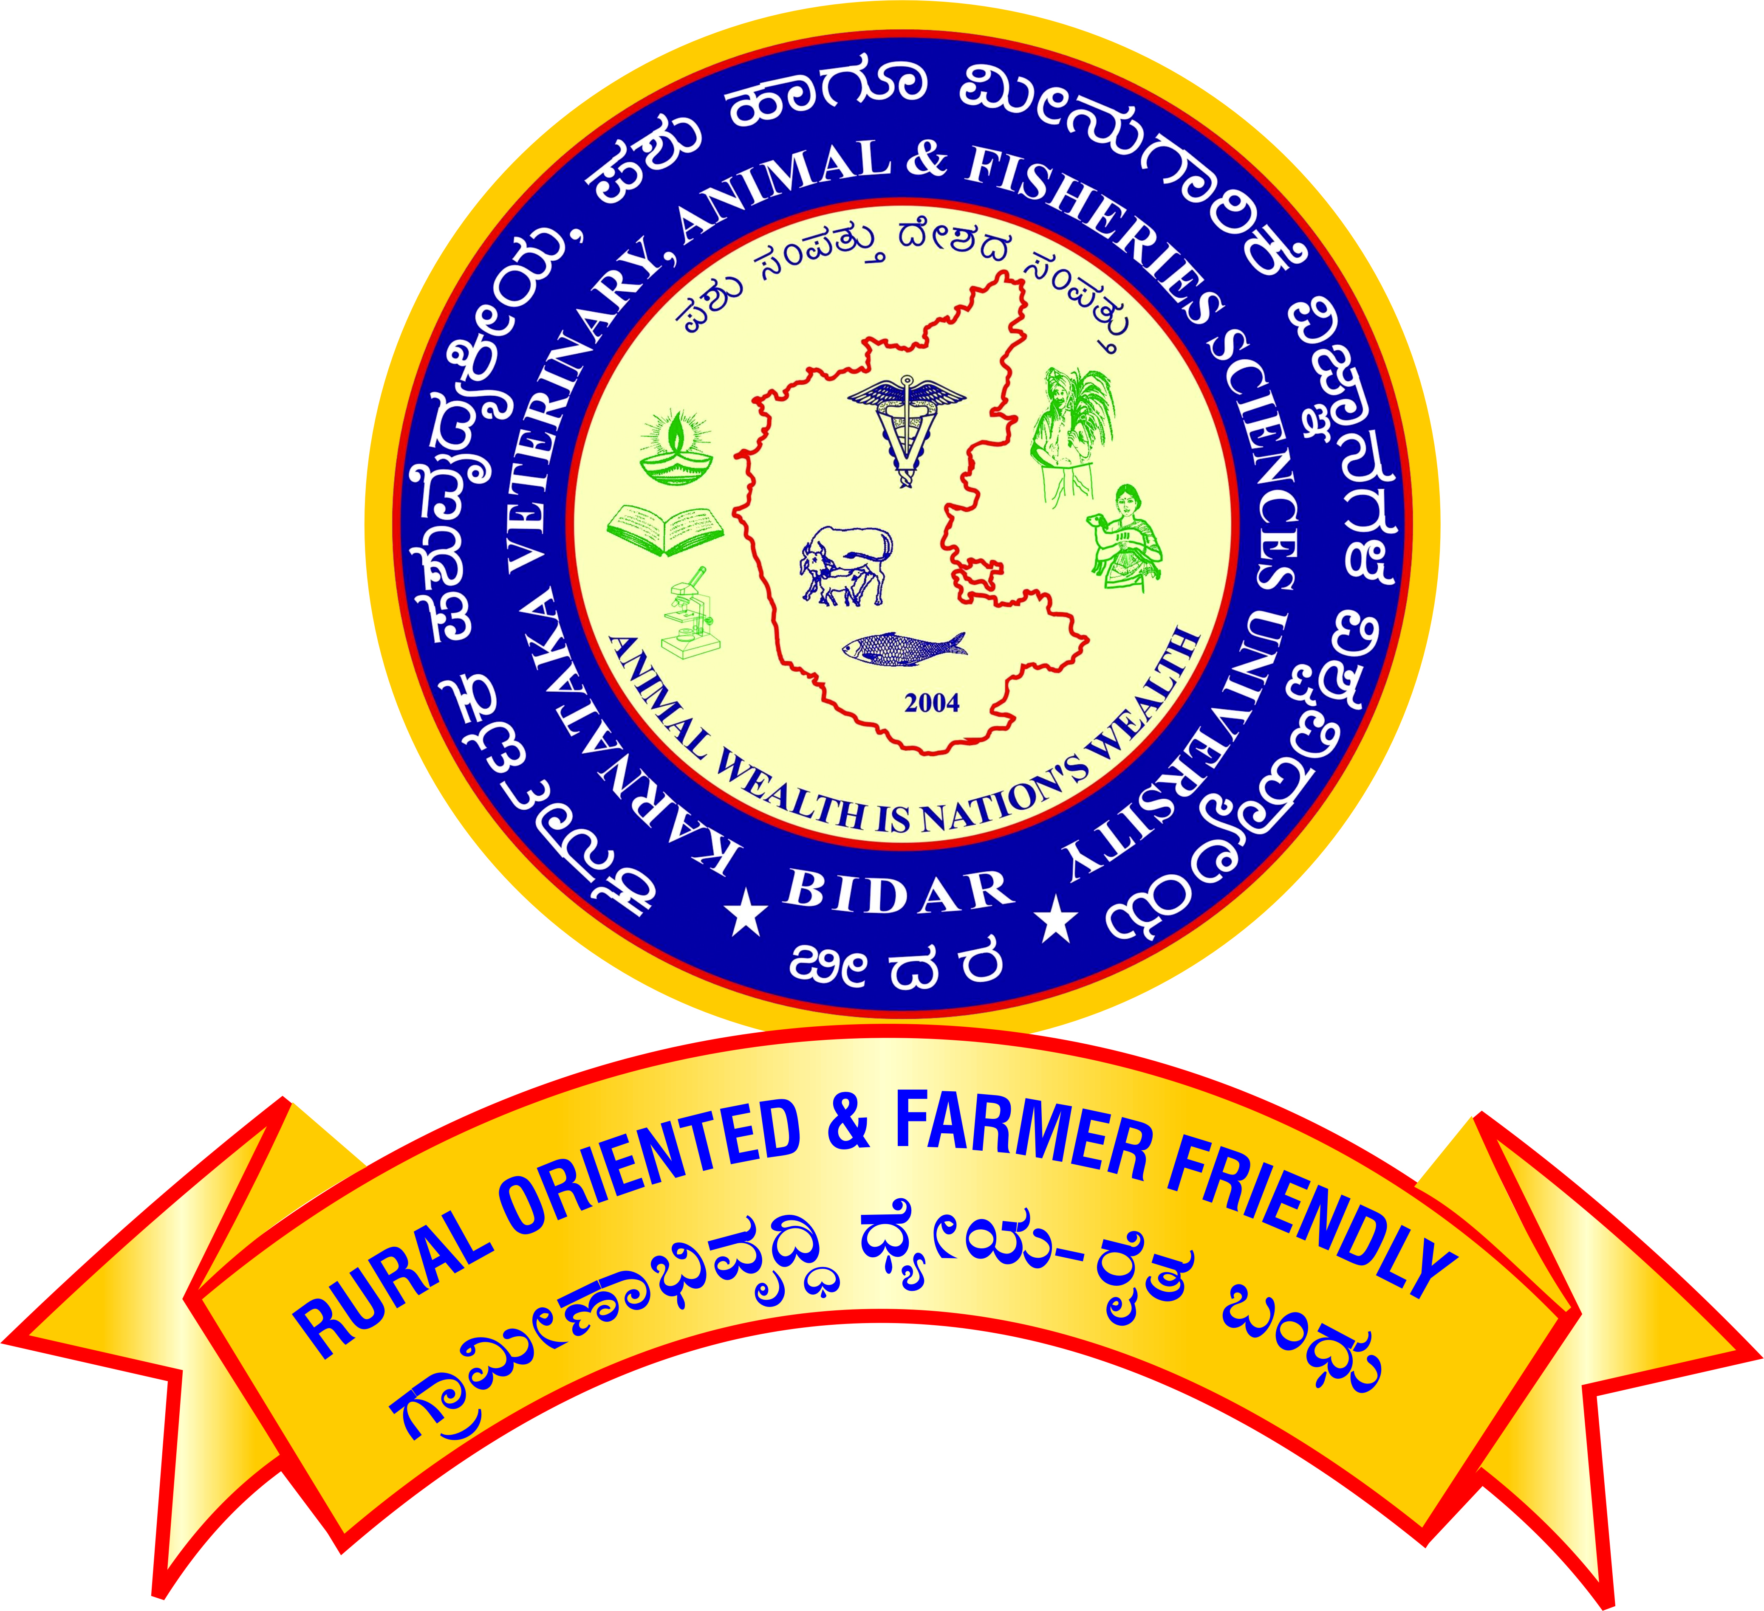
Nandi Nagar, PB No.6, BIDAR-585401, (Karnataka
Office of the Registrar
Phone : 08482-245241/245360

www.kvafsu.edu.in

PROFORMA TO APPLY FOR PROMOTION UNDER CAREER ADVANCEMENT SCHEME - 2016

ASSISTANT PROFESSOR OF PHYSICAL EDUCATION
(Academic Level 11 TO Academic Level 12)
[From Pay Band ₹ 68,900 to 2,05,500 TO Pay Band ₹ 79,800 to 2,11,500]

 | 1 |  | Name |  |  |  |  |  |  |  |  |  |  | Affix recent passport size photograph
 | 2 |  | Designation and full address
 | 3 |  | Name of the Department / Section / Unit / Scheme
 | 4 |  | Date of birth  (SSLC Marks Card – Mandatory)
 | 5 |  | Academic qualification
 | Examination / Degree |  |  |  |  |  |  | Year |  | Subject |  | University | Class / Division  / OGPA / CGPA
 | 6 |  | Date of joining to duty at KVAFSU, Bidar as Assistant. Professor of Physical education in the (Academic Level-10/AGP 6000)  (Enclose copies of the appointment order & duty report)
 | 7 |  | Date on which the pay band of ₹68,900 – 2,05,500 (Academic Level -11) was attained  (Enclose copies of the promotion order& duty report)
 | 8 |  | Date of completion of 5 years of service in the cadre of Asst. Prof. of Phy.Edu. in the pay band of ₹68,900 – 2,05,500 (Academic Level -11)
 | 9 |  | Performance/contribution of corporate Work during the assessment period  (Activities to be certified by competent authority)
 |  |  | a) |  |  | Organizing various inter campus/inter University Tournaments
 |  |  | b) |  |  | Serving as a team Manager/ Coach of the college Sports/Cultural teams in the Inter Campus/Local Tournaments
 |  |  | c) |  |  | Accompanying the University Sports/ Cultural team as a Manager/Coach
 |  |  | d) |  |  | Attending as-sports team selection committee member (State/ University/ District/Taluk Teams )
 |  |  | e) |  |  | Serving as Sports and Cultural Council Member of the University
 |  |  | f) |  |  | Serving as Technical Official/Experts outside the University
 |  |  | g) |  |  | Attending as Committee Member of Field Day/ Krishimela/ Convocation/ National Festival/ HSC /Disciplinary Committee or any Other activities assigned by the College/University.
 |  |  | h) |  |  | Other works attended by Physical Education Teacher
 |  |  |  |  |  | i) | Developing Sports Infrastructure like outdoor Games/ Gymnasium and indoor games.
 |  |  |  |  |  | ii) | Conducting sports activities in connection with the College day, Hostel day and during any other occasions.
10 |  | Published work during the assessment period
 |  | a) |  |  | For each full length article published in refereed journal
 |  | b) |  |  | For each book published/ edited
 |  |  |  |  | i) |  | Recognized publishers with ISBN
 |  |  |  |  | ii) |  | Chapters in standard books with ISBN
 |  |  |  |  | iii) |  | Published individually
 |  |  |  |  | iv) |  | Research/Extension Bulletin
 |  | c) |  |  | i) |  | For each research note/communication in a journal
 |  |  |  |  | ii) |  | Abstract in symposium/ seminar/ workshop/ training manual/proceedings of the workshop
 |  |  |  |  | iii) |  | Popular article/leaflet
 |  | d) |  |  | Any other publications::–
 |  |  |  |  | a) |  | As Author/Compiler of POP/Editor
 |  |  |  |  | b) |  | As Assoc. Editor/ Asst. Editor/Publisher/Compiler of other publications
11 |  |  | Summer Schools/Winter Schools/Refresher Course/Special Training/ Symposia/ Seminar/ Workshop/Conference/Coaching Camps
 |  |  | a) |  |  | For Organizing each activity as in the title  (i) Upto10 days  (ii0 More than10 days
 |  |  | b) |  |  | For participation in Summer School/Winter School/Refresher Course/  Orientation Course of 10 days duration
 |  |  | c) |  |  | For participation in a course/ programme from amongst the categories of Refresher course/ Research methodology course workshops/syllabus up gradation workshop/ Teaching- Learning Evaluation/ Technology Programmes/ Faculty Development Programme of at least ten days duration (or completed two course of at least five days duration in lieu of one MOOCs course in the relevant subject (with e-certification), or contribution towards the development of 10 modules of MOOCs course/ contribution towards conduct of a MOOCs course during the assessment period; and
 |  |  | d) |  |  | For participation in Special Training/ Orientation Programmes/ Symposia/ Seminars/ Conferences/ Workshops etc.(except Annual workshop)
 |  |  | e) |  |  | University Coaching camp for AIU /ICAR events/year/event
12 |  |  |  | International Exposure  International official Visits/ Training/ Courses (outside India only)
13 |  |  |  | Awards/ Distinctions received
 |  |  |  | a) |  | International award
 |  |  |  | b) |  | National award
 |  |  |  | c) |  | State award
 |  |  |  | d) |  | University award
 |  |  |  | e) |  | Professional Society Award
14 |  |  |  | Corporate / other activities
 |  |  |  | a) |  | Activities performed as External Examination Coordinator–Associate Coordinator/ Chief Warden/ Wardens/ Staff Advisor/Tour Leader and Co- Tour leader (State/ All India) /NSS Programme Officer–NSS /Indian Red Cross Society Programme Officer/ Coordinator /NCC Officer /Farm Management /Academic, General, Financial Management (as AO/ DAO/ AAO/Dy. R/ AR/ DC/ AC /Dy. Librarian /Asst. Librarian etc.)/ Scrutinizing UG/PG grades P.G. Co-ordinator/ Seminar In charge Leader/ Member in monitoring team.
 |  |  |  | b)  c) |  | Activities performed as Member- Co-chairman–Chairman of different committees of National–International–activities/RAWE–Assoc. Coordinator– participation in RAWE camp/ Internship/ Tournament Organized/ Spl. Officer of SC-ST Cell/ Minority Cell/Technical Assistant (Part-time)/ Students Counselor/ Leader for exposure visit of Farmers/ Liaison Officer for BOM/VIP’s tours assigned by the University/ Participation in Melas /Exhibitions as State, National, International levels representing University/Member/Co-Chairman in different committees of UAS activities/Team Manager and Co-Team Manager to Sports/ Cultural Activities/Stock verifying Officer/Antiragging squad member/ grade point conversion work/worked as Rapporteur/Co-Chairman in the National/ International Conferences, Seminars, Workshops/Symposium etc., Member of Class and Exam time-table committee, Press meet work/participation in UG&PG admission/ member involve in organization, selection of farmers/ Teachers for nomination to various awards.  Any other activities duly certified by the controlling officer/ University
15 |  |  |  | Outstation Service
16 |  |  |  | Any other significant achievement (with documentary proof)

Signature of the Asst. Professor of Physical Education

Verified that the information furnished by the Scientist / Teachers is correct.

Signature of the  Head of the Department / | Signature of the  Controlling Officer

